GraphX with backend RDDs had the problem that RDDs are non-structured to use in something highly structured like graphs.

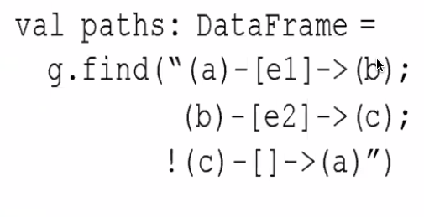

(): Represents Node

[]: Relationships

